Assignment A

Table of Contents

Task A

Task A.1

Task A.2

Task A.3

Task A.4

Task A.5

Task A.6

Task A.7

Ctrl + Left-click to follow hyperlinks.

## Task A

### Task A.1

Explain, in approximately 200 words, the reasons why customer service should be prompt and professional. Include three effects on the customer if it is not and three effects on the support organisation if it is not.

It is important that customer service should be prompt and professional as it provides multiple opportunities to improve both customer and employee satisfaction. When customers feel their concerns and issues are important to the support organisation, they are more likely to remain loyal to the brand; and encourage their friends and colleagues to use and share your products. When customers feel their concerns and issues are not important to the support organisation then they are more likely to be frustrated and resentful of bugs, corporate policies and outages.

Employee satisfaction is also an important aspect that can be affected by poor customer services. Employee satisfaction is often a reflection of customer satisfaction and can also have a negative feedback loop whereby employee frustrations are taken out on the customer and a self-perpetuating loop is created.

These types of issues can be avoided by ensuring the employee’s receive sufficient training and coaching to quickly identify and address customer problems. This results in a much better environment for your business to thrive.

To summarise and identify the key points of this essay:

3 effects on customers if customer service is not prompt and professional are:

1. Poor brand awareness
2. Negative public opinion
3. Abusive to employees

3 effects on the support organisation if customer service is not prompt and professional are:

1. Unhappy employees
2. Higher employee turn-over
3. Toxic work-place

### Task A.2

Describe three different ways of providing technical support, including at least one remote method (other than technical helpdesk).

Three ways of providing technical support are phone support, email support and remote desktop management.

Phone support involves trained and knowledgeable customer support representatives (CSRs) taking calls from customers to troubleshoot their technical support issues and queries.

Email support allows CSRs to provide simple, but detailed answers to customer queries and also takes the pressure off the organisation to have instant solutions available to customers.

Remote desktop management allows CSRs the option of logging into the customer’s computer and directly applying solutions to the customer’s hardware. Windows features this service directly, but other software suites can be employed to adapt to different needs. Examples of these software are LogMeIn and GoToAssist.

### Task A.3

Obtain a software update or patch as directed by your assessor. Save it onto a storage medium as instructed by your assessor. Rename the patch file to reflect what it is and what its use is.

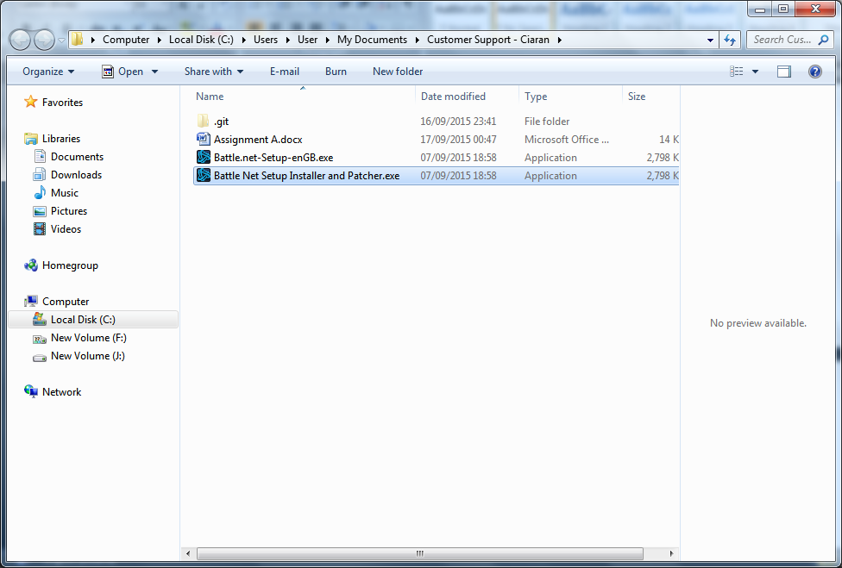

### Task A.4

Locate a hardware driver for a device as specified by your Assessor. Save it to disk.

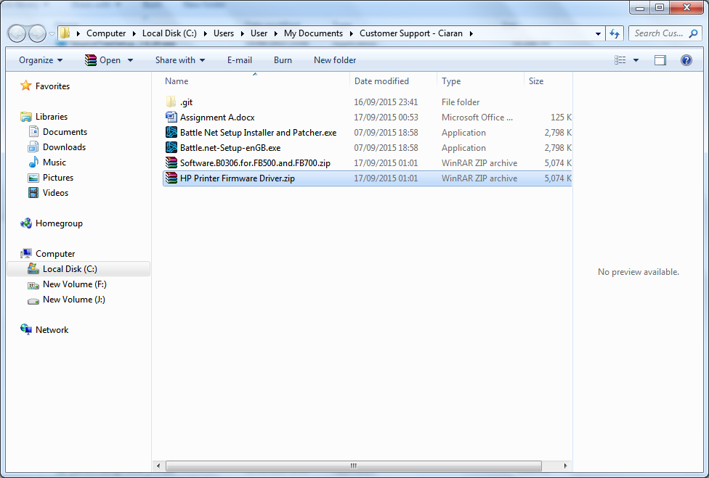

### Task A.5

Download an operator manual as directed by your Assessor. Save the document to a local drive or network location and check that you have the correct software to view the contents. Produce a screen print as evidence of the download.